Main Street Guitars

Ryan Dockstader

The Main street guitars website will allow any user to see the current stock of the store. It will show featured items or events at the top of the page, and then list all the guitars in an easy to read format. It will display to them a picture, the brand, the model, the price, and any available colors on the initial page. The user will then be able to view more information by clicking on the card. The user will also be able to search and filter the current guitar stock, making it easier for them to find exactly what they are looking for.

# Persona

Dylan is a single male. He recently graduated from college. He got his bachelor’s degree in

software engineering and found a job at a very successful startup during his last semester of school.

Currently Dylan is making a lot more money than he ever has in his life, so he has a pretty high

expendable income. He is married, and his wife will shortly be starting her senior year in college. Dylan

grew up loving guitars. He got a cheap electric guitar and amp in middle school and have been dabbling

ever since. He really loves to look at guitars and play as many as he can. Since he’s come into some more

money, he’s been really interest in buying a more expensive guitar and has been looking at Gibson and

Fender guitars at least once a week.

# Scenario

Dylan is really wanting to buy a new guitar and has decided to get a solid body electric guitar. He

keeps switching between a Fender American Elite Stratocaster in Aged Cherry Bust, and a Gibson Les

Paul Standard ‘60s in Bourbon Burst. He really wants to play them both so he can A/B them (he is a

software engineer now, after all) but doesn’t want to hop from shop to shop. He really wants to find a

shop that has them both so he can go play them, and probably purchase one.

# Criteria

|  |  |  |
| --- | --- | --- |
| Priority 1 | Priority 2 | Priority 3 |
| * Dylan isn’t going to want to wait for loading times, or search very long for website controls since he is going to be looking at serval different sites * The site must be very simple. It should show the guitars to the Dylan and show if they are in stock * Motivation is extremely important. The user should be motivated to visit the site regularly to check stock, prices, and reviews * The site needs to function well, and it needs to look good while doing it. If it looks like a site from the 90’s, people aren’t going to want to use it. | * The site needs to feel like a site that shows guitars. It needs to have filter and sort buttons in a similar place, and display information in a very digestible way * Mapping is important. The site needs to tell the user what button sorts, and what button filters * The price listed on the site should never be higher than it is in the store. However, if the price online is higher than the one on the store and the user decides to go in and check the store they will often be happy, and more likely to purchase it on the spot. | * There should be very little learning required to use the site, since it should follow standard practices |

# Snapshot

## Main Page

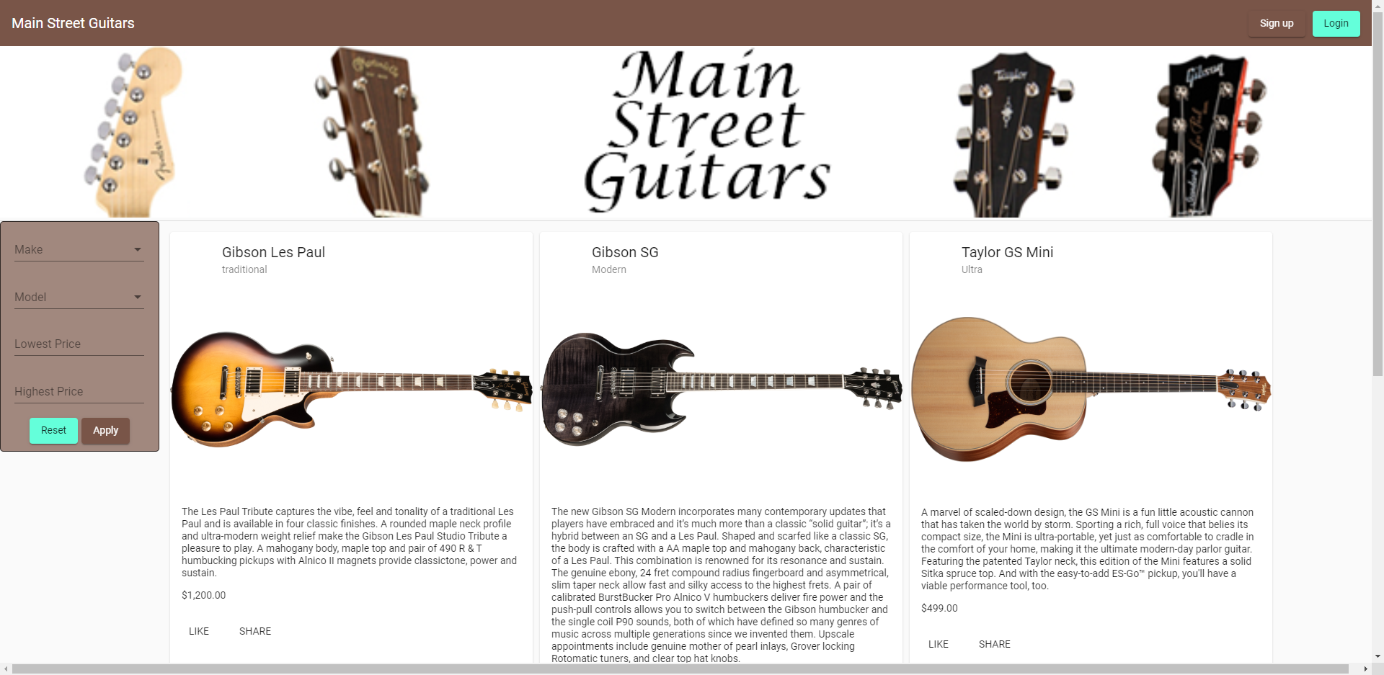

## Sign Up

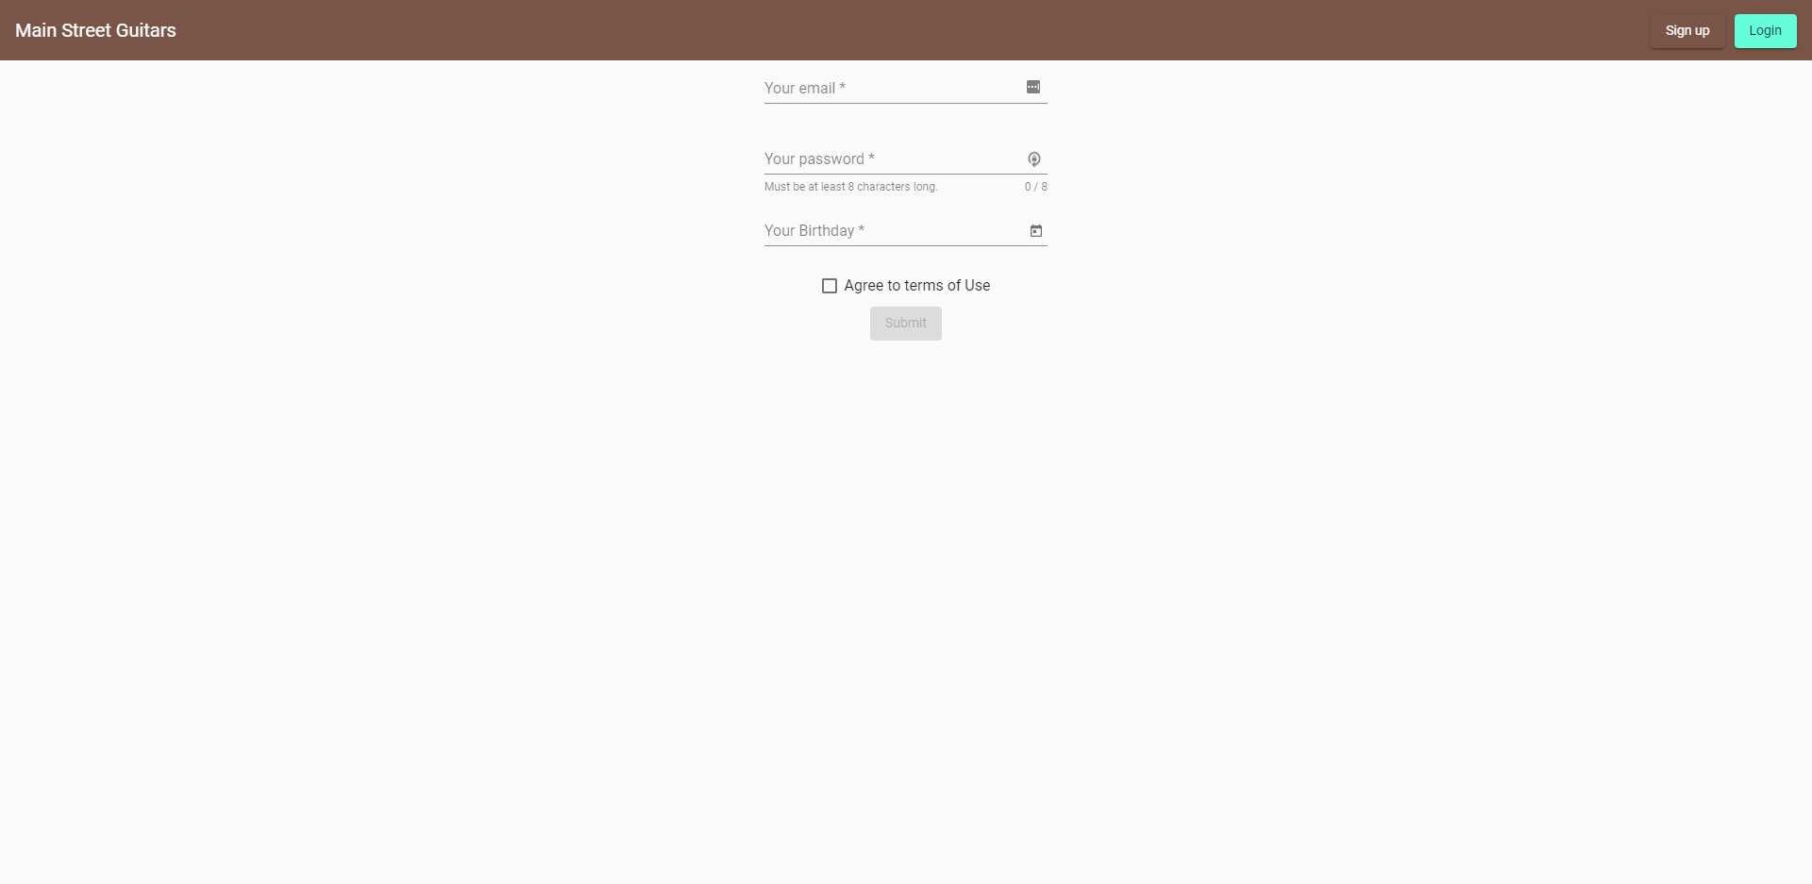

## Login

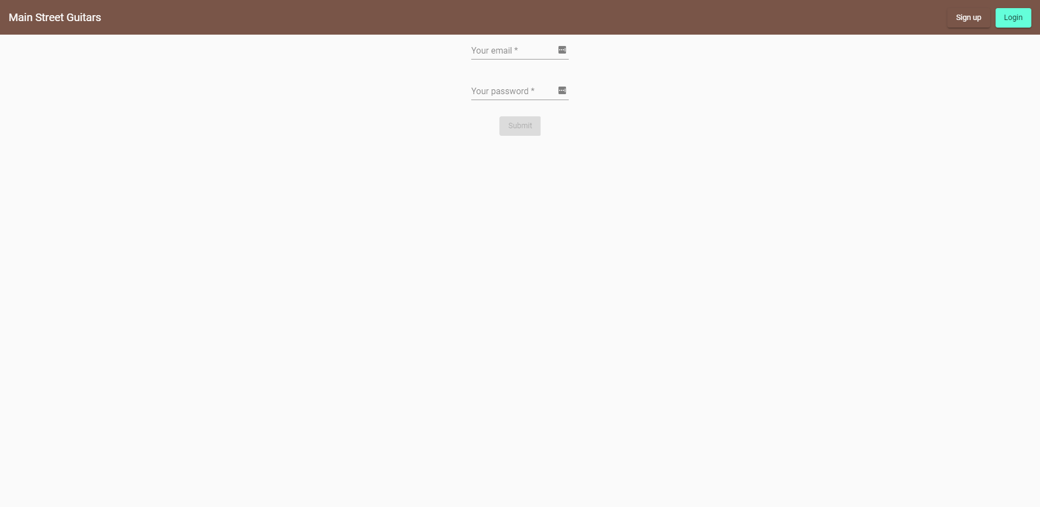

# Detailed Design

## Header

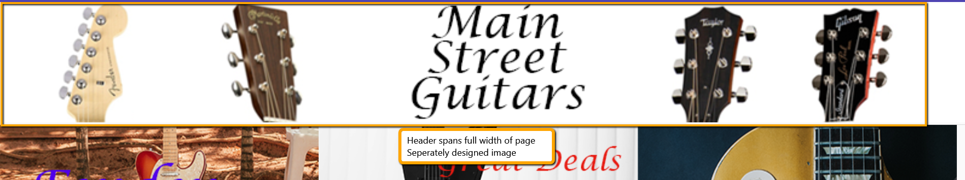

|  |  |
| --- | --- |
| Property | Value |
| Type | Image |
| Width | 100% |

## Filter

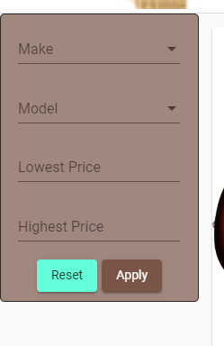

|  |  |
| --- | --- |
| Property | Value |
| Type | Expansion Panel |
| Width | As little of the page as possible |
| Contents | Contains optional filters |
| Function | Clicking a checkbox and hitting apply should apply the filter to the results in the Guitars section |

## Guitars

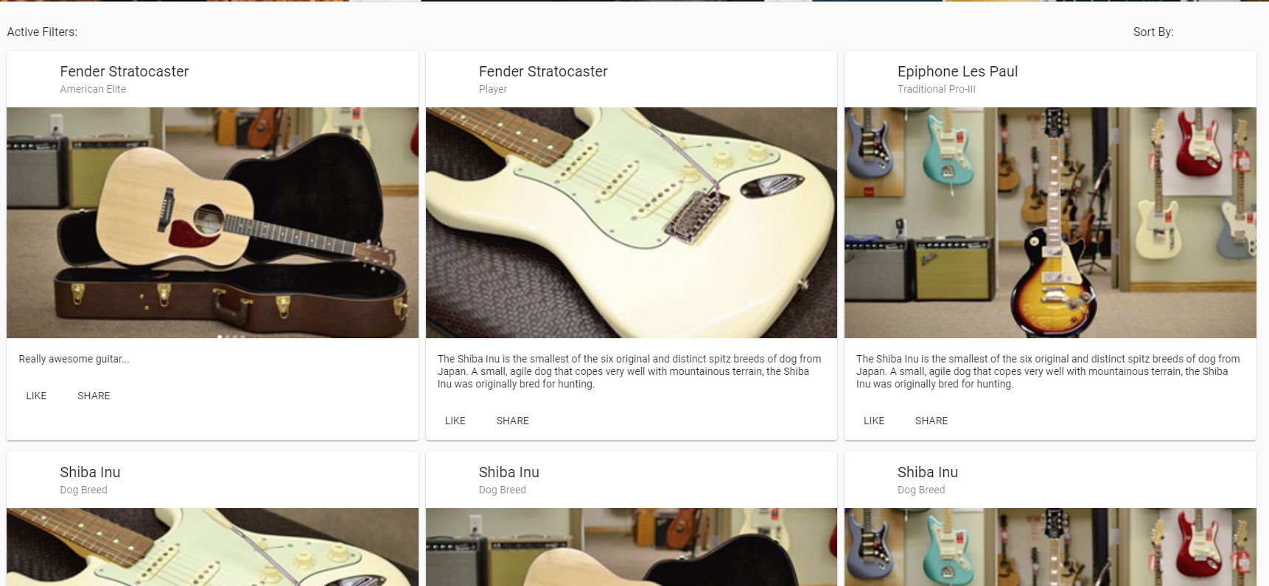

|  |  |
| --- | --- |
| Property | Value |
| Type | Section |
| Width | Everything the filter doesn’t take. |
| Contents | Guitar header, guitar cards |
| Function | Displays all the guitar cards in the system (filterable), as well as the guitar header |

## Guitars Header



|  |  |
| --- | --- |
| Property | Value |
| Type | div |
| Width | 100% of parent container |
| Contents | Displays the active filter, and sorting. |
| Function | Displays the active filter, and sorting. |

## Guitar Card

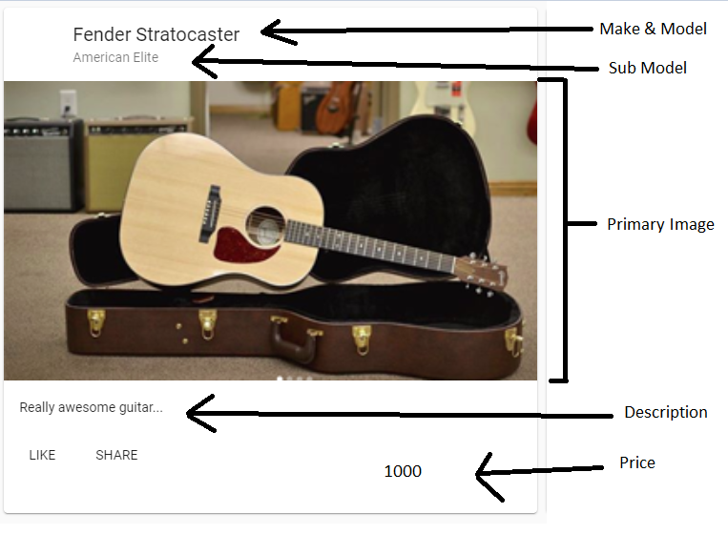

## Guitar Interaction buttons

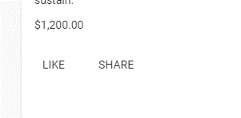

|  |  |
| --- | --- |
| Property | Value |
| Type | button |
| Styles | Material Button |
| Function (like) | Change button to LIKED, show a snack bar |
| Function (share) | Initiate the share guitar dialog |

## Share Dialog

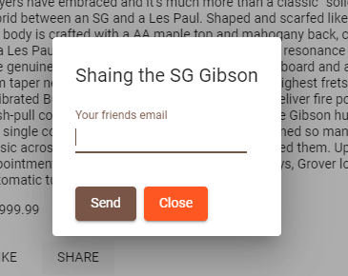

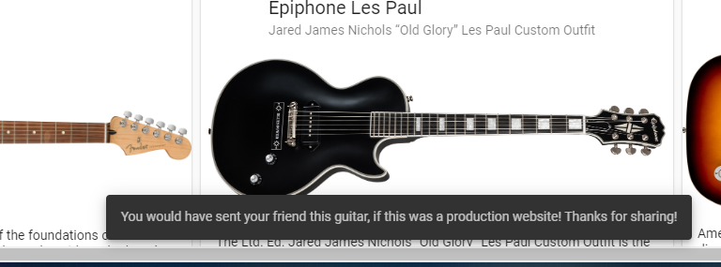

# Appendix

## Security

Security will be handled through the framework, and the backend. Not authenticated users will not be allowed to like or share. Non admin users will not be able to access the admin screens.

## Accessibility

All image tags will have an alt, the site will have a description and be broken into logical sections. We will use Google Lighthouse to assess accessibility

## Internationalization

Internationalization is not needed at this time

## Product Support

This will be supplied on an as needed basis and will be outside of the standard contract.

## Change History

|  |  |
| --- | --- |
| Date | Change |
| 10/13/2019 | Executive summary was created |
| 10/14/2019 | Prototype of main pages designed |
| 10/18/2019 | Persona, scenario, and criteria defined |
| 10/22/2019 | Prototype began, started on angular. Built nav bar, login and sign up pages |
| 10/23/2019 | Designed basic header, and three feature cards |
| 10/24/2019 | Built filter and guitars section header, and cards |
| 10/25/2019 | Added snapshots and detailed design sections, and appendix |
| 12/10/2019 | Removed the features and feature card sections on the detailed design |
| 12/11/2019 | Updated the screen captures to reflect the changes in the UI |
| 12/11/2019 | Add Guitar interaction buttons to detailed design |
| 12/11/2019 | Add share dialog to detailed design |
|  |  |

## Issues

|  |  |
| --- | --- |
| Issue | Explanation |
| Framework | The framework as picked to be Angular, since it has a very dynamic material design library that should provide most of what is needed to build the site |
| Backend | If there is a backend, Firebase will be used as it requires no building and worked great with the framework, as both are designed by google |
| Limited Admin Menus | We are limiting the admin menus as to avoid complications inside the application. With limited changes, this limits the ability to cause breaking changes within the site. |